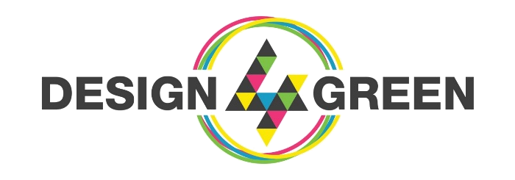

**SYNTHESE DU PROJET CHALLENGE DESIGN4GREEN 2021 REPORT**

Numéro d’équipe / Team Number : 24

**GT MTERIX**

SCORE (PageSpeed Score) : 100% (only percentage)

SCREENSHOT (with Day and time)

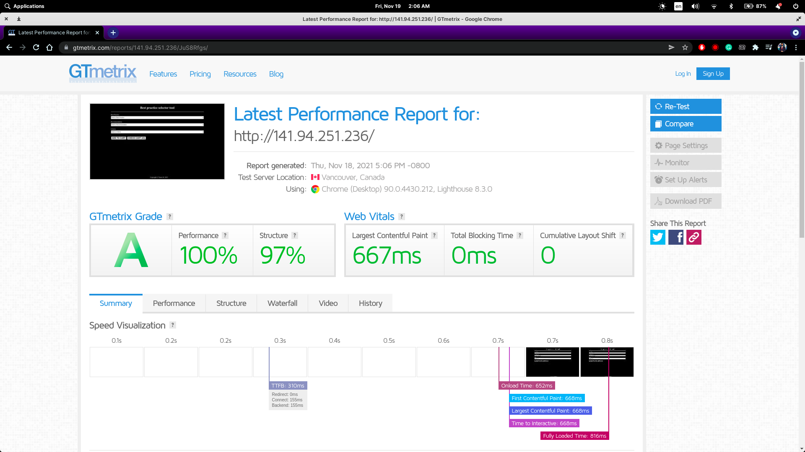

**ECOINDEX**

SCORE (Performance environnementale / Environmental performance ) : 81.68/100

SCREENSHOT (with Day and time)

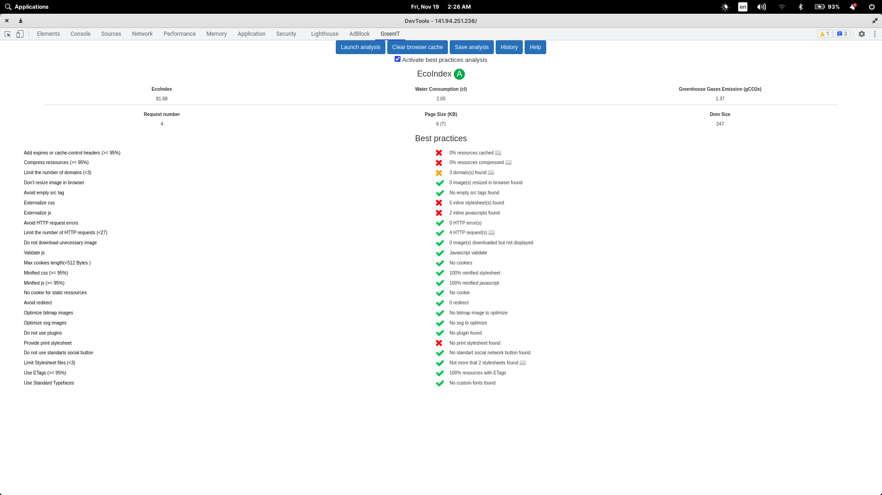

**ECOGRADER**

SCORE : 64 / 100

SCREENSHOT (with Day and time)

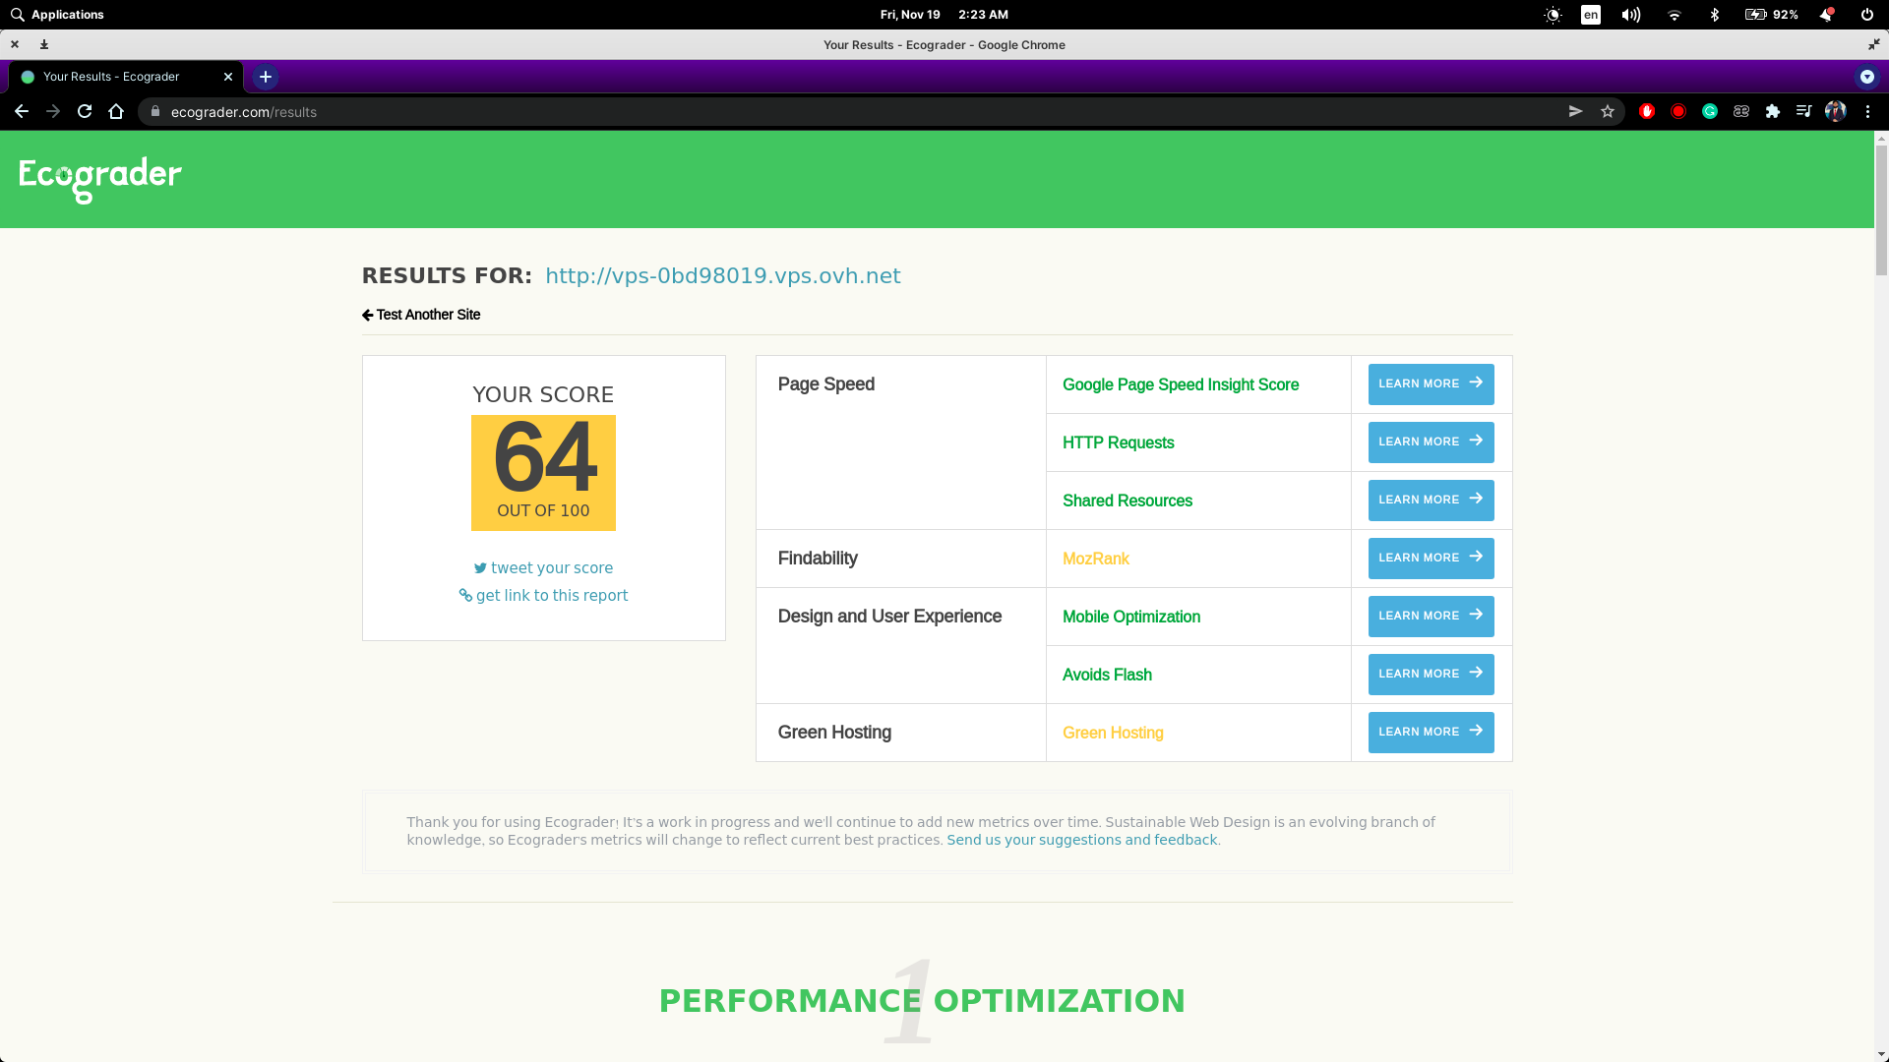

**Conception générale – General conception**

Avez-vous réussi à finaliser votre projet ? Did you manage to finish your project ? Oui Yes / Non No

Si non, pourquoi et quels éléments sont manquants ? if not, why and what is missing ?

Yes, we managed to finish our project.

**Conception technique – Technical conception**

Quel langage avez-vous choisi et pourquoi ? which language did you use and why ?

We decided to use python and javascript. Flask provides a small and lightweight (therefore assists in reducing response time) Python web framework which has excellent documentation (therefore, simpler to develop in a time crunch). Furthermore, web apps developed with Flask are pretty straightforward to deploy. Javascript was utilized because it operates on the client side (therefore, server side network load does not have heavy impacts) as well as provides interoperability with other languages.

Comment avez-vous optimisé vos requêtes ? How did you optimize the query ?

Retrieving data from database using multiple query is more time costly than retrieving data from csv for one time and using this with the help of python dictionary. So we ignored database and used python dictionary to optimized the run time.

**Conception fonctionnelle – Functional conception**

Avez-vous choisi d’utiliser un outil de représentation graphique ? Did you us a graphical representation ? Oui Yes / Non No

Si oui pourquoi ? if yes, why ?

No

Si non pourquoi ? if not Why ?

We opted not to use a graphical representation because it was not explicitly mentioned to provide a graphical interface. It is always the greenest to perform functions that are specified by the client. Furthermore, graphical representations might include images, which itself is not green to begin with.

**Design**

Expliquez en quelques mots les choix réalisés au niveau du design du site? Explain your design choices ?

Our primary design goal was to minimize page load time and building a green website. So we identified all components those can be forfeited while maintaining a good user experience. So we avoided using logos, images as those were not adding good values. We also took steps to ensure our website only loads minimum required assets such as using default typeface.   
  
To make sure the design is green we did not use any plugins. Raw design ensures minimal weight on the front end and server. We also used as less js as possible and kept the theme dark.

**Accessibilité**

Qu'avez-vous mis en place pour le respect de l'accessibilité du site? How did you manage the accessibility of your site ?

To manage accessibility of our website we used ARIA role in all sections.

**QUESTIONS GÉNÉRALES – GENERAL QUESTIONS**

Qu'est ce qui fait que votre site est éco-conçu? Why your solution is ecodesign ?

Firstly we followed good number of best practices for green website ensuring minimal yet complete design. Secondly We used lightweight tools to have the fastest response time and minimal load on the front end and the server. Thirdly we saved lot of memory and computation time by loading data only once per session directly from the CSV .

Avez-vous d'autres remarques pertinentes sur votre projet ? others comments on your project ?